**DAILY ONLINE ACTIVITIES SUMMARY**

|  |  |  |  |  |  |  |  |
| --- | --- | --- | --- | --- | --- | --- | --- |
| **Date:** | **06/07/2020** | | | | **Name:** | **Syed Rabeya Aamir** | |
| **Sem & Sec** | **8th B** | | | | **USN:** | **4AL16CS112** | |
| Online Test Summary | | | | | | | |
| **Subject** | | **__** | | | | | |
| **Max. Marks** | | **__** | | **Score** | | **---** | |
| Certification Course Summary | | | | | | | |
| **Course** | **INTRODUCTION TO CYBER SECURITY.** | | | | | | |
| **Certificate Provider** | | | **Great Learning** | **Duration** | | | **5.5 hrs** |
| Coding Challenges | | | | | | | |
| **Problem Statement:**  **1)**  Python program to clear a list using clear() method. | | | | | | | |
| **Status: Solved** | | | | | | | |
| **Uploaded the report in Github** | | | | **YES** | | | |
| **If yes Repository name** | | | | **rabeya** | | | |
| **Uploaded the report in slack** | | | | **YES** | | | |

**Certification Course Details:**

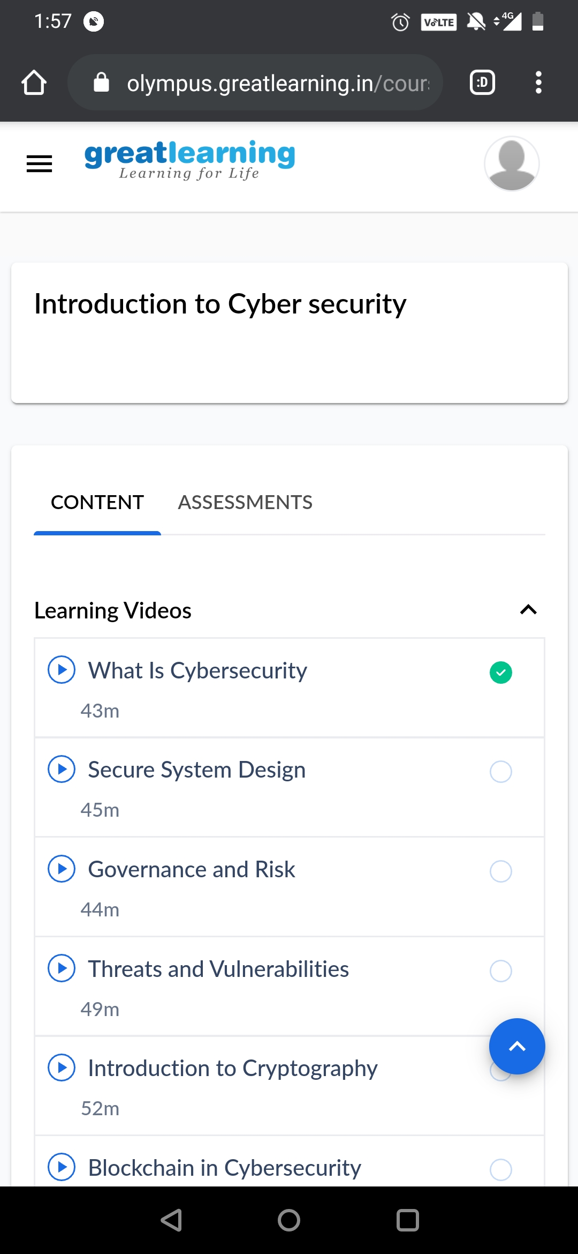

# CODE:

Program no:1

# Python program to clear a list using clear() method

# Creating list

TAGS = [6, 0, 4, 1]

print('TAGS before clear:', TAGS)

# Clearing list

TAGS.clear()

print('TAGS after clear:', TAGS)